THE USE OF HULL-LESS BARLEY IN THE DIET OF BROILER CHICKEN

FILIP KARÁSEK¹, ONDŘEJ ŠŤASTNÍK¹, HANA ŠTENCLOVÁ¹, EVA MRKVICOVÁ¹, LEOŠ PAVLATA¹, KATEŘINA VACULOVÁ², PETR DOLEŽAL¹, LADISLAV ZEMAN¹

¹Department of Animal Nutrition and Forage Production, Faculty of Agronomy, Mendel University in Brno, Zemědělská 1, 613 00 Brno, Czech Republic
²Agrotest fyto, s.r.o., Havlíčkova 2787/121, 767 41 Kroměříž, Czech Republic

Corresponding email address: karasek89@seznam.cz

ABSTRACT

The aim of this study was to determine the effect of hull-less barley addition to the feed ration for fattening male broilers of hybrid Ross 308. The effect on feed consumption, weight gain and carcass yield were evaluated. The content of hull-less barley in experimental diet was 30 and 60%. The control diet contains 30 and 60% of common wheat. Differences between groups in performance parameters were not significant (P > 0.05). Our results suggest that the difference between feeding barley and wheat was not significant. The hull-less barley can be considered as a potential feed for broilers, respectively, as a possible replacement for a certain amount of wheat in feed for broilers.

Keywords: hull-less barley; carcass yield; poultry nutrition

INTRODUCTION

In most European countries, wheat and barley are the most commonly used cereal grains in poultry and pig feeds (Inborr et al., 1993).

MATERIAL AND METHODS

An experiment was performed with cockerels of Ross 308 hybrid
(n = 96) which were fattened in cage batteries from day 20 to day 43 of age. Cockerels were divided into 4 groups. Two experimental groups of chickens received feed containing 30% or 60% of hull-less spring barley, line KM 1057-1906 (group JB30 and group JB60, respectively) and two control groups received 30% or 60% of common wheat (groups C30 and C60, respectively). The spring barley line KM 1057-1906 with hull-less grain was obtained from the company Agrotest fyto, s.r.o. The content of beta glucans was 3.9%, dry matter 93.0%, crude ash 2.3%, crude protein 15.2%, crude fat 2.8%, crude fibre 3.5% and brutto energy 16.8 MJ/kg.

Table 1. Composition of the diet in individual groups (g/kg)

Component | JB60 | C60 | JB30 | C30
Corn 9% of crude protein | 78 | 56 | 354.5 | 348
Cornstarch | 21.5 | 12 | - | -
Soybean meal < 3.5% of fibre | 210 | 242 | 256 | 273
Sunflower oil | 50 | 50 | 50 | 40
Limestone 37.5 % of Ca | 3 | 3 | 3 | 3
Monocalcium phosphate 24% P | 6 | 6 | 6 | 6
Lysine 78% | 1.5 | 1 | 0.5 | -
Premix | 30 | 30 | 30 | 30
Hull-less barley | 600 | - | 300 | -
Wheat CONTROL | - | 600 | - | 300

Data has been processed by Microsoft Excel (USA) and Statistica version 12.0 (CZ). We used one-way analysis at variance (ANOVA). To ensure evidential differences Scheffe's test was applied and differences were considered significant at P < 0.05.

RESULTS AND DISCUSSION

The highest total feed consumption during the experiment (from 20th to 43rd days of age) was found in the experimental group JB60, namely 3.82 kg per chicken. The lowest total feed consumption for this period was achieved in the group C30, namely 3.67 kg. In JB30 and C60

Figure 1. Average individual feed consumption (g/day/chicken of trial)

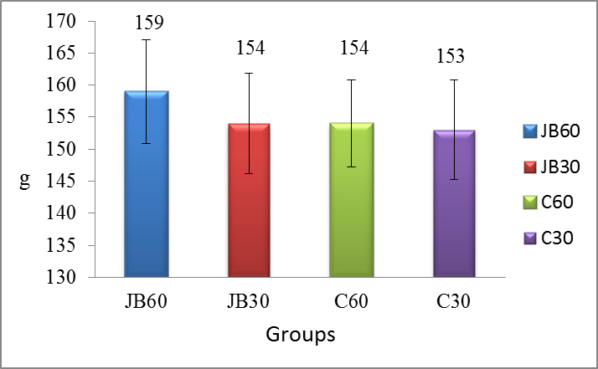
The highest average live weight at the end of fattening was achieved in the experimental group JB30 with value 2,914.41 ± 80.48 grams, while the lowest weight was observed in the experimental group JB60 2,685.33 ± 148.09 grams (Figure 2).

CONCLUSION

Our results suggest that the difference between feeding barley with hull-less grain and wheat was not significant in any parameters. Nevertheless, the experimental groups fed hull-less barley in feed mixtures resulted in convenient growth performance and carcass traits. In our experiment it was found that the addition of higher amounts of hull-less barley in feed mixtures caused the worse carcass yield only by 1 - 2%. The hull-less barley can be considered as a potential feed for broilers, respectively, as a possible replacement for a certain amount of wheat in feed for broilers.

ACKNOWLEDGEMENT

The project was supported by the TP IGA MENDELU 4/2015.

REFERENCES

Almirall, M., Francesch, M., Perez-Vendrell, A.M., Brufau, J., Esteve-Garcia, E. (1995): The differences in intestinal viscosity produced by barley and β-glucanase alter digesta enzyme activities and ileal nutrient digestibilities more in broiler chicks than in cocks. Journal of Nutrition 125, 947-955.
Anonymous (2014): Technological procedure for broiler Ross [online]. Aviagen Group 2014. Available from: http://en.aviagen.com/ross-308. (accessed Feb 21, 2015).
Elwinger, K., Saéterby, B. (1987): The use of β-glucanase in practical broiler diets containing barley or oats. Swedish Journal of Agricultural Research 17, 133-140.
Graham, H., Pettersson, D. (1992): A note on the effect of a beta-glucanase and a multi-enzyme on production in broiler chicks fed a barley-based diet. Swedish Journal of Agricultural Research 22, 39-42.
Guenter, W. (1993): Impact of feed enzymes on nutrient utilization of ingredients in growing poultry. Journal of Applied Poultry Research 2, 82-84.
Inborr, J., Schmitz, M., Ahrens, F. (1993): Effect of adding fibre and starch degrading enzymes to a barley/wheat based diet on performance and nutrient digestibility in different segments of the small intestine of early weaned pigs. Animal Feed Science and Technology 44, 113-127.
Jamroz, D., Jakobsen, K., Bach Knudsen, K. E., Wiliczkiewicz, A., Orda, J. (2002): Digestibility and energy value of non-starch polysaccharides in young chickens, ducks and geese, fed diets containing high amounts of barley. Comparative Biochemistry and Physiology, Part A, 131, 657-668.
Kirchgessner, M., Eder, K., Muller, H.L., Jamroz, D. (1999): Zur energetischen Bewertung von Nichtstarke-Polysacchariden beim Geflugel. Journal of Animal Physiology and Animal Nutrition 81, 51–55.
Li, W. H., Xiao, X. L., Zhang, W. H., Zheng, J. M., Luo, Q. G. (2014): Compositional, morphological, structural and physicochemical properties of starches from seven naked barley cultivars grown in China. Food Research International, 58, 7–14.
Onderci, M., Sahin, N., Cikim, G., Aydin, A., Ozercan, I., Ozkose, E., Sahin, K. (2008): β-Glucanase-producing bacterial culture improves performance and nutrient utilization and alters gut morphology of broilers fed a barley-based diet. Animal Feed Science and Technology, 146, 87-97.

